Ahmed Shalaby

Examination System

Business Requirements document V 1.0

|  |  |  |  |
| --- | --- | --- | --- |
| No | Name | Job | Signature |
| 1 | Eng./Ahmed Shalaby | ………….…….. | ………. |
| 2 | Eng./Ahmed abdel-fattah | ……………. | …….. |
| 3 | Eng./Abdel-hamid | …………… | ……….. |

**Project manager**

Eng./..Sara

Signature / ...........................

**Table of Contents** System Requirement sheet

Abstract ......................................................................................................................... 3

Project Objectives.......................................................................................................... 3

System Requirement Sheet............................................................................................ 4

ERD................................................................................................................................4

Views..............................................................................................................................5

Back_up Daily...............................................................................................................8

Users ............................................................................................................................10

Create Database............................................................................................................11

DDL .............................................................................................................................12

DML ............................................................................................................................16

**Abstract**

Examination System Database is SQL Server Project which is a System designed for use in Show exams and create it automatically .

This system will store correct answer and check student answer and store his result.

Allow Student to Show his Exam and his degree’s

Allow instructor to insert student to courses

**System Objective**

1. File to create database **Named** : SQLQuery2.sql
2. File DDL **Named** : SQLQuery3.sql
3. File DML **Named** : SQLQuery4.sql
4. File Views **Named** : SQLQuery6.sql
5. File Triggers **Named** : SQLQuery1.sql
6. File store_procedure **Named** : SQLQuery5.sql

**System Requirement sheet**

1. Operating System : Windows 7 or higher
2. System Type : 32 bit Systems or higher
3. Required RAM : At least 2GB of RAM
4. SQL Server Version : 2012 or higher

**ERD**

**Views**

1. view student_class

1. view student_class_inst  
   Graphical user interface, text, application

   Description automatically generated
2. view Course_inst  
   Graphical user interface, text, application

   Description automatically generated
3. view Inst_Ques

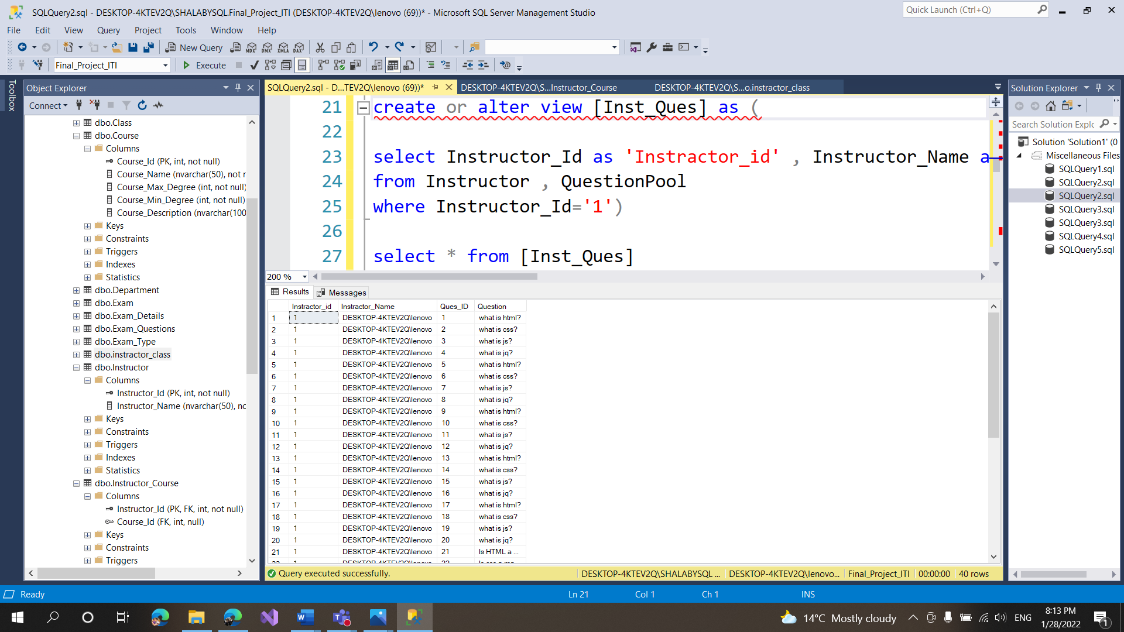

5- view Std_Course  
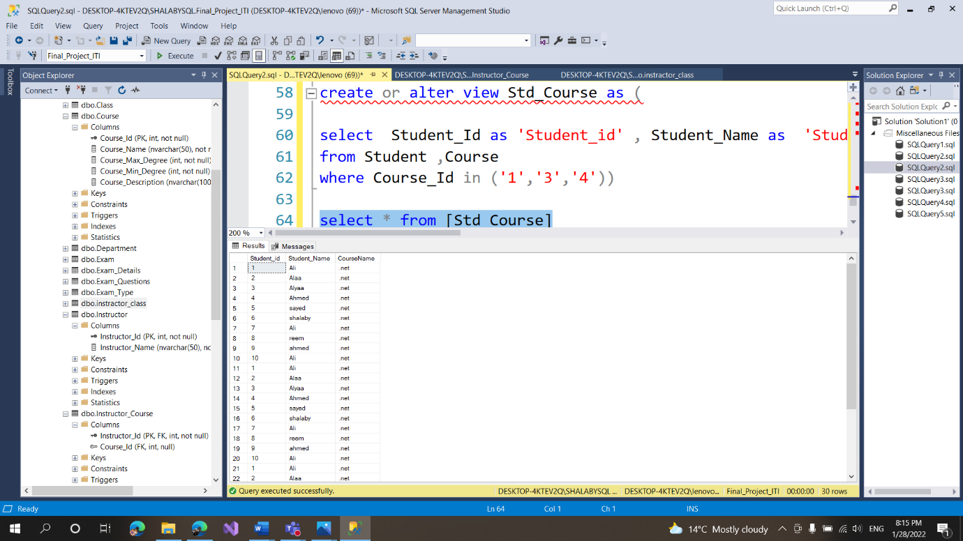

**Back_up**

**Users**

1. name :Windowns authentication

1. name : instractorusername: instractor  
   Password : 456
2. name : studentusername: student  
   Password : 123
3. name : managerusername: manager  
   Password : 1234

**Create Database**

**DDL**

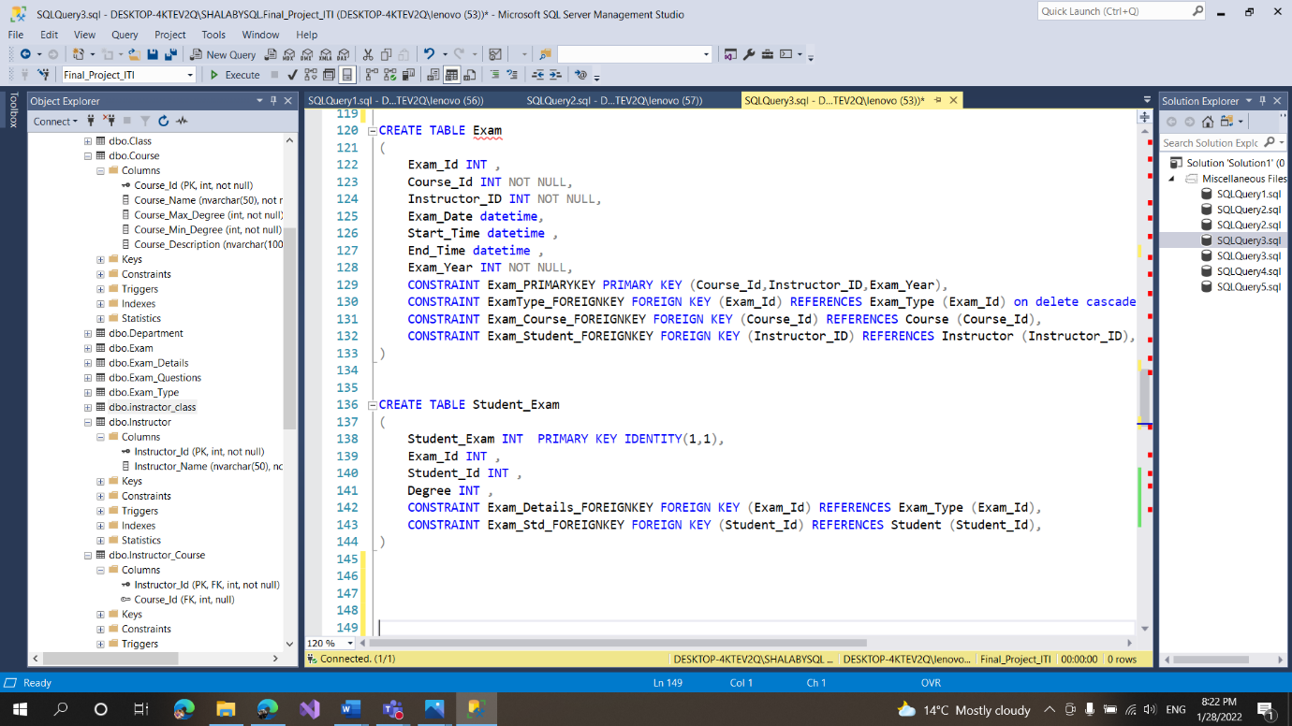

**Dml:**

